Ideation Phase
Brainstorm & Idea Prioritization Template

Date | 31 January 2025
Team ID
Project Name
Maximum Marks | 4 Marks

Brainstorm & Idea Prioritization Template:
Brainstorming was used to generate and discuss multiple data analytics project ideas in a collaborative environment. Each idea was evaluated based on its business relevance, data availability, visualization potential, and practical impact. After prioritizing the ideas, Visualizing Housing Market Trends: An Analysis of Sale Prices and Features using Tableau was selected as the most suitable project. It provides valuable insights into how factors such as house age, renovations, bathrooms, bedrooms, and floors influence sale prices. The project uses interactive Tableau dashboards to present trends and patterns, helping stakeholders make informed, data-driven decisions in the real estate market
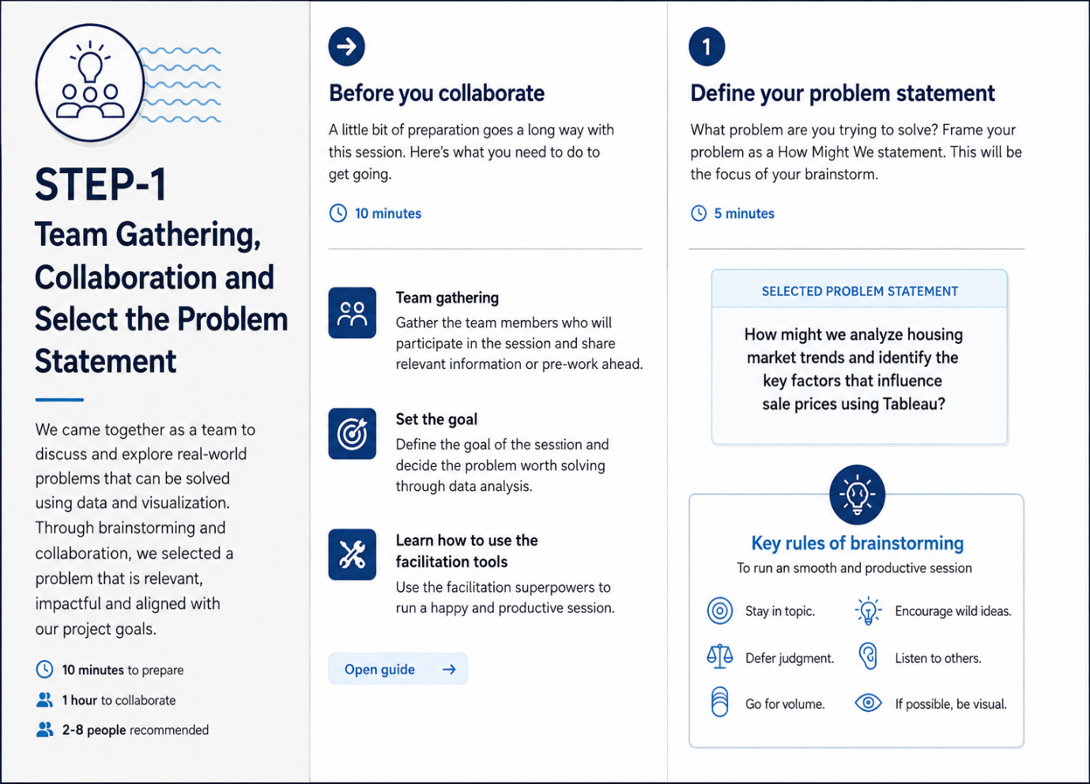
Step-1: Team Gathering, Collaboration and Select the Problem Statement

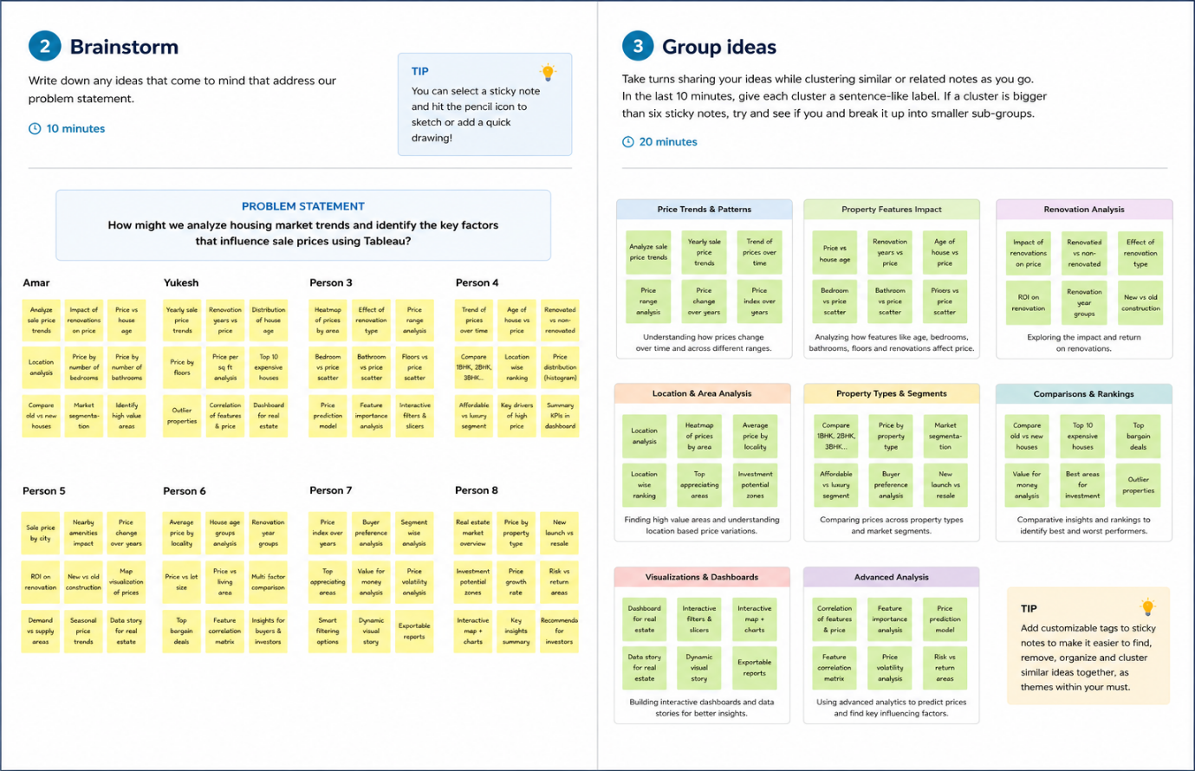
Step-2: Brainstorm, Idea Listing and Grouping
Step-3: Idea Prioritization
